MINI PROJECT REPORT On
Embedded system and IoT Design
Design and Implementation of an Automotive Body Control Module using Arduino and TFT Display

Mohammed Basith
B.E ECE
311823106036

Abstract:
This mini project focuses on the design and implementation of an Automotive Body Control Module (BCM) using Arduino Uno and a TFT Display. The project demonstrates the fundamentals of embedded systems, sensor interfacing, automotive electronics, and Human-Machine Interface (HMI) development. The BCM controls essential vehicle body functions such as headlights, turn indicators, temperature monitoring, and fault detection. A TFT display is used as a dashboard interface to provide real-time system information. The project simulates the working of a modern automotive BCM and provides a practical understanding of vehicle electronics and embedded control systems..
Objectives:
• To understand the fundamentals of embedded systems and automotive electronics.
• To design and implement an Automotive Body Control Module using Arduino Uno.
• To control vehicle headlights and turn indicators.
• To monitor temperature using the LM35 sensor.
• To provide fault detection and alert mechanisms.
• To display vehicle status information using a TFT display.

Literature Survey:
Automotive Body Control Modules have become an essential component in modern vehicles due to increasing electronic integration. Traditional vehicles used independent wiring systems for each body function, resulting in increased complexity and maintenance requirements.
Modern BCMs centralize the control of multiple vehicle functions, reducing wiring complexity and improving reliability. Advanced BCMs communicate with other vehicle ECUs through protocols such as CAN Bus.
This project presents a simplified BCM prototype using Arduino Uno and TFT display technology. It provides practical exposure to embedded systems, sensor interfacing, fault detection, and automotive dashboard developmen

Components Required:
S.No | Component Name | Quantity | Explanation
1 | Arduino Uno | 1 | Main controller used for processing inputs and controlling outputs
2 | ST7735 TFT Display | 1 | Displays dashboard information and vehicle status
3 | LM35 Temperature Sensor | 1 | Measures temperature continuously
4 | Buzzer | 2 | Generates fault warning alerts
5 | Push Buttons | 1 | Used for headlight and indicator control
6 | Breadboard | 1 | Used for building and testing electronic circuits without soldering components permanently.
7 | Jumper Wires | As required | Used to connect different electronic components on the breadboard and microcontroller board.
8 | Power Supply | 1 | Supplies electrical power required for operating the ESP32, sensors, and other electronic components.

Software used:
• Arduino IDE
• Embedded C/C++
• SPI Communication Protocol

Working principle:
The Arduino Uno continuously reads inputs from switches and the LM35 temperature sensor.
When the headlight switch is activated, the Arduino energizes the relay and turns ON the headlight indicator. Similarly, the left and right indicator switches control the respective LEDs.
The LM35 sensor measures temperature and sends analog signals to the Arduino. The controller converts these values into temperature readings and displays them on the TFT dashboard.
If the measured temperature exceeds the predefined threshold value, the system enters fault mode. During this condition:
• The buzzer is activated.
• A fault warning message is displayed on the TFT screen.
• The driver is alerted about abnormal operating conditions.
All system parameters are continuously updated on the TFT display, providing real-time monitoring functionality.

Features:
• Real-time vehicle monitoring
• Headlight control system
• Left and right indicator control
• Temperature monitoring using LM35
• Fault detection and warning system
• TFT-based dashboard interface
• Automotive embedded system simulation
• Low-cost and efficient design
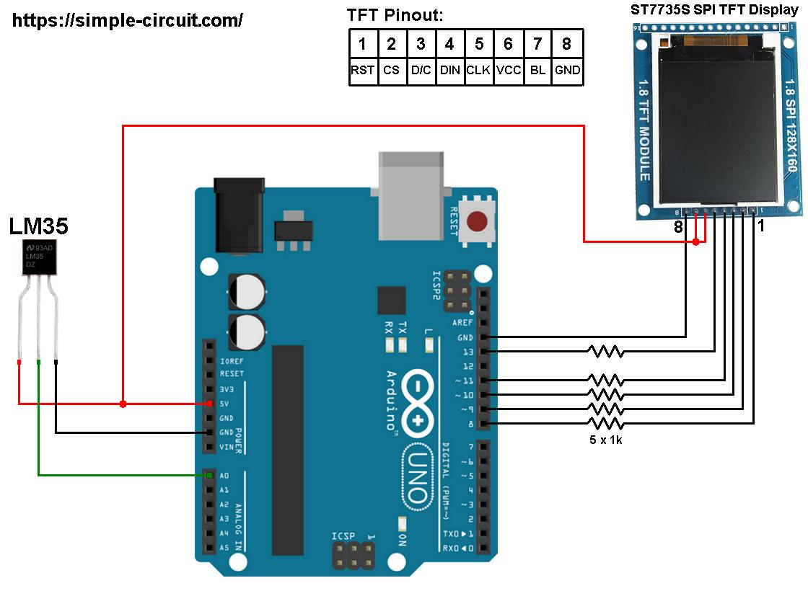

Outcome:
Successfully implemented an Automotive Body Control Module using Arduino Uno.
Controlled headlights and turn indicators using embedded programming.
Displayed real-time vehicle status on TFT display.
Detected abnormal temperature conditions and generated warning alerts.
Demonstrated practical automotive embedded system functionality.
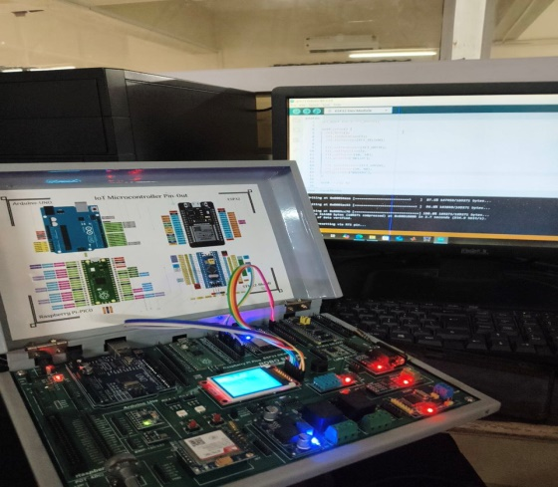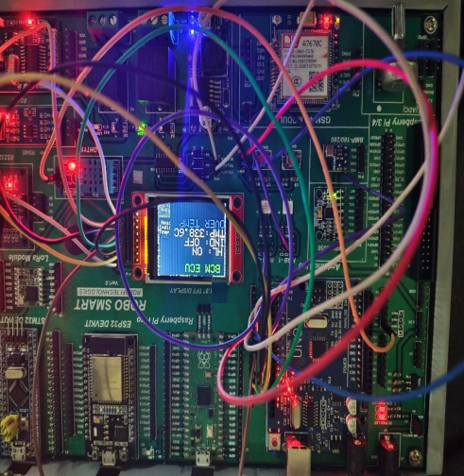

Future Enhancements:
- CAN-based ECU communication
- FreeRTOS task scheduling
- Diagnostic Trouble Codes (DTC)
- Graphical dashboard
- EV battery temperature monitoring

Conclusion:
The Design and Implementation of an Automotive Body Control Module using Arduino and TFT Display was successfully completed. The system effectively monitored temperature, controlled vehicle lighting functions, detected faults, and displayed real-time information through a dashboard interface.
The project provides practical knowledge of automotive electronics, embedded systems, and Human-Machine Interface development. It serves as a foundation for advanced BCM and ECU development used in modern automobiles.

References:
- Arduino Uno Official Documentation.
- ATmega328P Datasheet.
- Adafruit ST7735 TFT Display Documentation.
- Raj Kamal, Embedded Systems: Architecture, Programming and Design.
- Frank Vahid and Tony Givargis, Embedded System Design.
- Automotive Electronics Handbook.

